Nama : widyawati nur sholikhah

Kode : FSDO002ONL002

get semua data

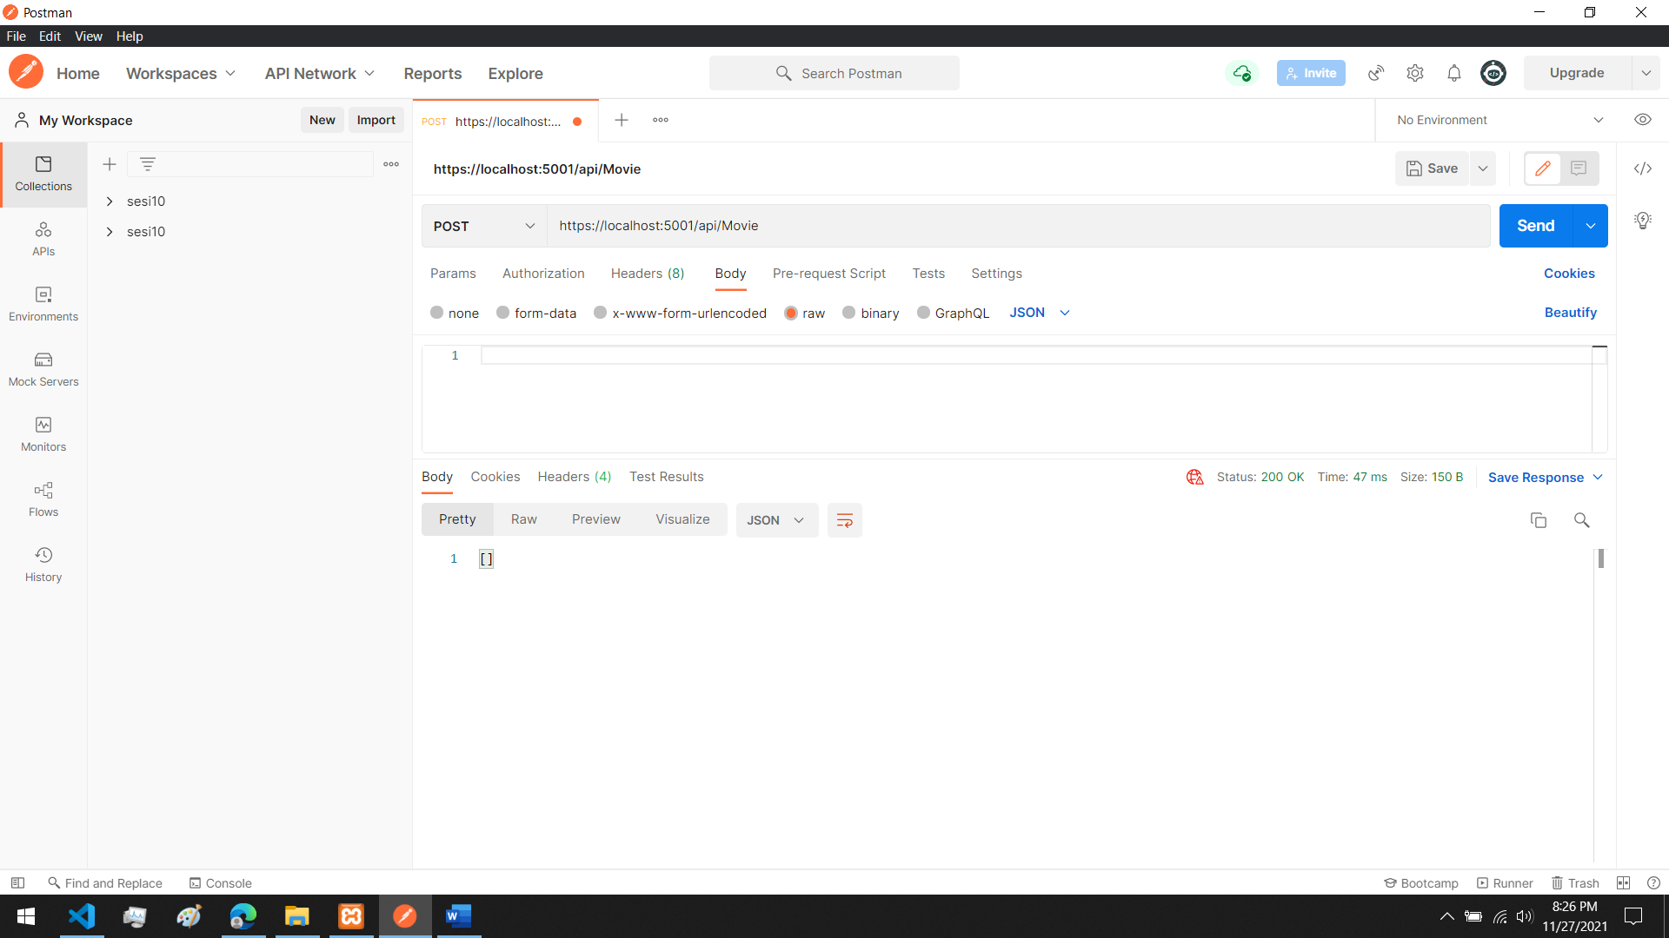

Post data

Get semua data sudah ditambahkan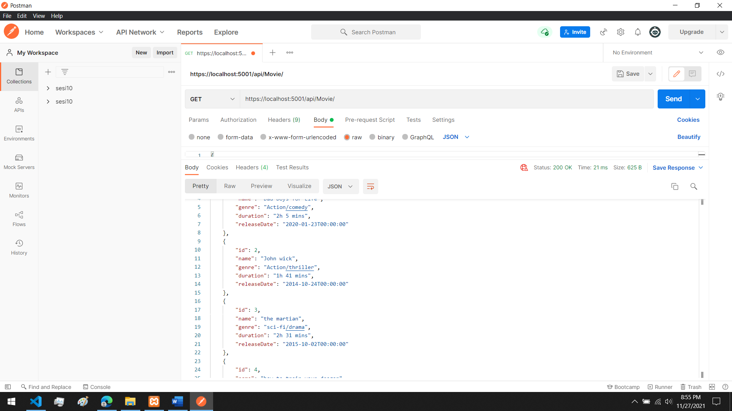

Get data menggunakan id 3

Data dengan id 3 terhapus

